Detailed Game Specification:
ALIEN ABDUCTION
Course: COMP 2659, Winter 2016
Instructor: Paul Pospisil
Authors: Brady Kirchner, Matt Powaschuk
Last Modified: April 13, 2016

General Game Overview
Alien Abduction is an arcade style shoot-em-up game. The player controls a UFO which initially appears in the center of the screen. A horizontal line separates the bottom 8 pixels from the rest of the screen, such that everything below this line is considered the “ground”, while everything above the line is considered the “sky”. The player-controlled UFO flies around the sky in an up, down, left, or right direction. The UFO may not however fly off-screen. If the UFO comes into contact with the left, right, or the top edge of the screen, this edge is considered an invisible barrier and the UFO with be blocked from moving any further. On the ground human soldiers will appear from the left or right edge of the screen, moving horizontally to the opposite edge. The object of the game is to collect as many points as possible before the game ends. Points are scored by pressing the space bar to shoot a beam of light from the UFO downwards onto the soldiers, “abducting” them (which erases them from the screen). Each human hit by a beam is worth 10 points. Additionally, fighter-jets will appear in the sky at various time intervals, either flying right to left or left to right along the screen. The fighter-jets appear at varying heights and are the enemies of the UFO, attempting to destroy it by colliding with it. In the top left corner of the screen, the player’s score is displayed, as well as the number of “lives” they have remaining. They player starts with 3 lives, and each life is considered 1 play-through. A life is removed when the UFO “dies”. A death occurs when the UFO collides with a plane, a missile, or the ground. When no lives remain, the game is over.
Single-Player Gameplay
The player controls an alien UFO flying in the air over flat ground. The objective is to abduct soldiers which walk along the ground, they generate at one per 2 second. Every time a soldier is abducted the player gets a point. To oppose them, planes will fly horizontally across the screen. The game will start with planes moving relatively slowly across the screen, but the more points a player collects, the planes will start moving faster. If the player collides with a plane, a soldier, or the ground, they despawn, which removes the ship and resets them at the center of the screen, in a "safe" vertical range where no planes are currently traversing, and lose a life. If the player has any lives left they will respawn in the center of the screen, in the safe range. The player has three lives, once a player loses all of their lives, the game ends. Alternatively, they can end the game by pressing the 'p' key. To abduct soldiers, the player must send a beam down to the ground, to do this, they must be at least halfway up the playable area. Any soldiers caught in its range are instantly abducted, which removes the soldier sprite, and a point is gained. After firing a beam the player must recharge it for five seconds before using it again.
On both sides and at the top of the screen, the player is blocked from exiting the window by a harmless collision. The UFO’s beam range is decided by its height projected from its position to the ground where the soldiers walk. The width of the beam is equal to the width of the ship. The beam can travel as far as it needs to reach the ground.
In the end, there is no "winning", the player simply aims to get the highest score they can.
User Input
One of WASD, when held down, will move the player in that direction at a fixed rate. When no keys are held down, the ship hovers in place. The spacebar will fire the beam. The 'p' key is pressed to exit the game.
Example of Gaming Session
The player will start the game with the UFO in the middle of the screen, and the first soldier and the first plane will spawn with the player. they will immediately attempt to start abducting the soldiers to gain points. Slowly, as they capture more soldiers, planes will move faster, these planes move horizontally in one of the two directions, with a maximum of three going in a direction. This continues until the player dies three times, losing a life from their total each time, at which point the game is finished.

Objects
UFO - 32 X 32 (Pixels)
This object spawns in the middle of the screen three times per game. It will respawn each time it is destroyed if a life remains. The user input will control the behavior of this object, including its movement and firing its beam. This object keeps track of its current score (Based on the amount of soldiers its abducted), number of lives remaining, and whether its beam is recharging. Finally, it will keep track of whether it is temporarily invincible due to recently spawning. The UFO can move at a speed of 12 pixels/move in any WASD direction..
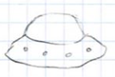

Enemy plane - 32 X 24
This object spawns at either side of the screen periodically, at random heights in such a way that the lowest part of the plane is always above soldiers, and the highest part is always lower than the top of the map. Two planes will never collide as they won't be spawned at a height if it would collide with another plane, the map object will keep track of "occupied" pixels in height before spawning any of these. There will be a maximum of 6 planes at a time (3 per direction). They move horizontally until they reach the other side, at which point they despawn. The game will spawn planes once per second (if it does not exceed maximum planes), and the planes' speed will start at 3 pixels/move but will increase at the following intervals: 5 pixels after 100 points, 6 pixels after 200 points, 8 pixels after 500 points, and 10 pixels after 1000 points. If the plane object collides with the UFO, the UFO is destroyed and the plane continues on it's path. Two planes will never collide as they won't be spawned if it would collide with another plane, the map object will keep track of "occupied" pixels in height before spawning any of these.
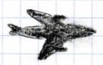
Soldier - 8 x 8
This object also spawns at a random side of the screen, on ground level (details in Map), once per 2 seconds, and moves horizontally until it reaches the other side, at which point it despawns. it's speed is set at 2 pixels/move, there is a maximum of 10 soldiers at any time on the screen. If a UFO beam collides with the Soldier, the soldier despawns and the UFO that fired the beam gains a point. If the UFO and a soldier collide, the soldier is destroyed. The player does not gain a point for destroying a soldier, soldiers do not collide with each other.
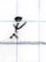

Beam - 16 X 170
This object spawns from the bottom of a UFO for only an instant. It has a width equal to that of the UFO and reaches all the way to the ground. It keeps track of how many soldiers it has caught, relaying that information back to the UFO object. The beam is visible for half a second, during which the UFO and soldiers are temporarily locked in place.
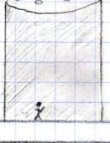
Map - 640 X 350
This object holds data related to the gameplay area, including all the buffers, it is also used when spawning to determine which areas are safe to spawn in, as the map will keep track of all "occupied y" rows.

Scoreboard - 100 X 50
This object spawns in the upper left of the screen for UFO 1, and in the top right for UFO 2, if playing in 2-player. It will hold data relative to each UFO's score and will display this score in a small window, this score will give the players a sense of how dangerous the planes are getting, as their movement speed increase. The lives are represented by small 16X16 sprites of the UFO, the score is represented by 0-9 bitmap digits, the scoreboard can fit a number up to 5 digits in size, and the player labels are either “player 1” or “player 2” text bitmaps.
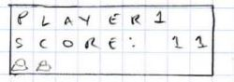
Events
Asynchronous
When the user holds down one of WASD, it will set a request to move the UFO each game loop.
When the user presses the spacebar and if a beam is ready to be used, a request to fire the beam will be sent.
Synchronous
Every two seconds, a soldier will spawn at a random side of the map, on the ground.
Every second, a plane will spawn at a random side of the map, at a random height. This height will be a determined such that the lowest part of the plane cannot collide with any soldiers and that the highest part of the plane is lower than the top of the map.
Condition based events
When a request to move is detected, the UFO is moved 12 pixels in the requested direction, if it can, also checking for collisions that would destroy the UFO.
When a request to fire the beam is made, the beam will spawn underneath the ship for a half-second and captures any soldiers it collides with, awarding a point to the UFO.
There are many possible collisions, here is a list of collision cases:
UFO vs. ground
The UFO will be despawned, a life is taken from the UFO, the ground remains unaltered.
UFO vs. soldier
The soldier is despawned, no point awarded.
UFO vs plane
The UFO is despawned and a life is lost, the plane remains unaltered..
UFO vs upper and side limits
The UFO will be unable to continue in the direction that would take them off the screen, but will not lose a life.
Planes, and soldiers vs side limits
The plane, or soldier is despawned, nothing else changes.
Soldier vs Soldier
The soldiers simply pass through each other.
Beam vs Soldier
The soldier is despawned, and the UFO which fired the beam gains a point.
2-Player Gameplay
2-Player gameplay is similar to single-player gameplay, however each player controls their own UFO on the same map. The players compete against each other, trying to abduct as many human soldiers as possible. The player who abducts the most soldiers is the winner. Gameplay continues until both players run out of lives completely. If two UFOs overlap with each other on-screen, they will simply pass through each other and no collision occurs. if two UFOs fire a beam that collide with the same soldier, the one who fired first gets the abduction.

Sound Effects
Sound Effect Name | Brief Description | Event which Triggers Playback
Beam | One short beep in quick succession | UFO fires a beam
Explosion | White noise at high volume, with quick decay | Player UFO is destroyed
Music | X-files theme song | Start of game, loops throughout
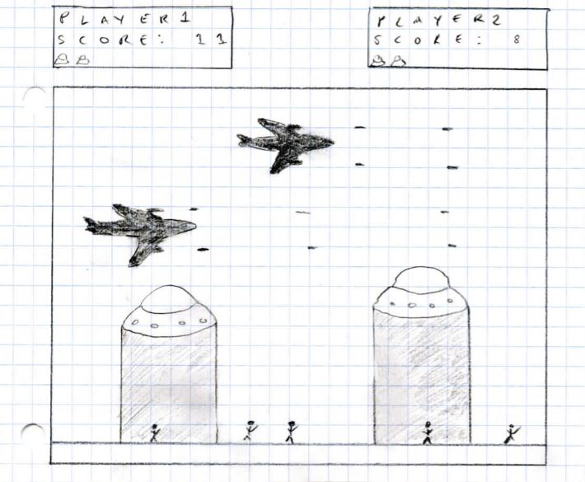

Additional Features (Time Permitting)
Depending on how quickly the programming process goes, we’d like to add certain additional features such as:
Player Power-ups:
In 2-player mode, power ups will randomly appear on the screen. The first UFO that collides with the power-up will receive the benefit of the power-up. These benefits include increased speed, additional lives, a wider and more powerful beam, and potentially others.
Ground Guns:
In addition to planes flying across the screen, ground artillery will shoot at the UFOs from ground level. This may include tanks moving across the screen or a stationary gun in the middle of the screen firing skyward in different directions.
Diagonal movement:
In addition to being able to move in the WASD directions, the UFO would be able to move in all 4 diagonal directions as well.

